Créer un jeu du pendu

JS / CSS / HTML

Structure

Le jeu sera divisé en 3 classes:

1. Classe Hangman:
constructor()
render(container_id) // generates the HTML and places it in the container
start(container_id) // starts a game and renders it in the container

2. Classe Word:
constructor(string)
positionsFor(letter) // returns the positions in the word for that letter, or null if not present

3. Class Database:
constructor()
random() // return a random guess (string word + string clue)

La liste des mots et des indices se trouve en annexe.
L’image est disponible sur http://www.flashbynight.com/tutes/hangmanhtml5/man.png

On dispose de maximum 7 chances pour deviner le mot, sauf si le mot contient moins de 7 caractères, alors on le nombre de chances est égal à la longueur du mot.

Résultat:

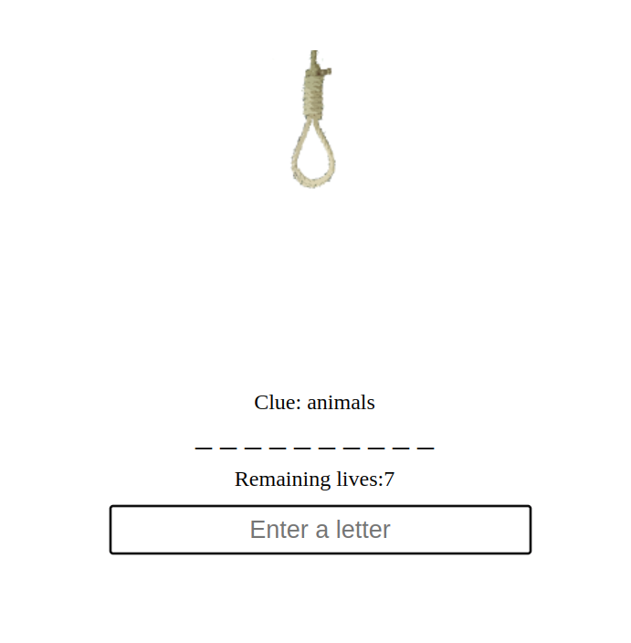

Exécution

Les caractères vides, ou les suites d’espace ne sont pas prise en compte.
Si plusieurs caractères sont entrés rapidement, le jeu annule l’entrée

Votre HTML inclus le fichier JS App.js
Votre App.js ne contiendra que

import Hangman from './Hangman.js';
let hangman = new Hangman();
hangman.start('game');

Annexe

class Database{
constructor(){
this.words = [
{"word": "giraffe", "clue": "animals"},
{"word": "lion", "clue": "animals"},
{"word": "tiger", "clue": "animals"},
{"word": "elephant", "clue": "animals"},
{"word": "monkey", "clue": "animals"},
{"word": "leopard", "clue": "animals"},
{"word": "penguin", "clue": "animals"},
{"word": "gazelle", "clue": "animals"},
{"word": "hippopotamus", "clue": "animals"},
{"word": "rhinoceros", "clue": "animals"},
{"word": "crocodile", "clue": "animals"},
{"word": "kangaroo", "clue": "animals"},
{"word": "platypus", "clue": "animals"},
{"word": "cheetah", "clue": "animals"},
{"word": "puma", "clue": "animals"},
{"word": "lizard", "clue": "animals"},
{"word": "snake", "clue": "animals"},
{"word": "tortoise", "clue": "animals"},
{"word": "ford", "clue": "cars"},
{"word": "ferrari", "clue": "cars"},
{"word": "porsche", "clue": "cars"},
{"word": "lamborghini", "clue": "cars"},
{"word": "bmw", "clue": "cars"},
{"word": "audi", "clue": "cars"},
{"word": "mercedes", "clue": "cars"},
{"word": "jaguar", "clue": "cars"},
{"word": "tesla", "clue": "cars"},
{"word": "skyscraper", "clue": "buildings"},
{"word": "bridge", "clue": "buildings"},
{"word": "tower", "clue": "buildings"},
{"word": "cathedral", "clue": "buildings"},
{"word": "temple", "clue": "buildings"},
{"word": "museum", "clue": "buildings"},
{"word": "palace", "clue": "buildings"},
{"word": "library", "clue": "buildings"},
{"word": "stadium", "clue": "buildings"},
{"word": "computer", "clue": "technology"},
{"word": "smartphone", "clue": "technology"},
{"word": "tablet", "clue": "technology"},
{"word": "laptop", "clue": "technology"},
{"word": "television", "clue": "technology"},
{"word": "printer", "clue": "technology"},
{"word": "camera", "clue": "technology"},
{"word": "headphones", "clue": "technology"},
{"word": "bluetooth", "clue": "technology"},
{"word": "router", "clue": "technology"},
{"word": "grapes", 'category': 'food'},
{"word": "banana", "clue": "food"},
{"word": "orange", "clue": "food"},
{"word": "strawberry", "clue": "food"},
{"word": "kiwi", "clue": "food"},
{"word": "pineapple", "clue": "food"},
{"word": "mango", "clue": "food"},
{"word": "apple", "clue": "food"},
{"word": "pear", "clue": "food"},
{"word": "peach", "clue": "food"},
{"word": "plum", "clue": "food"},
{"word": "lemon", "clue": "food"},
{"word": "lime", "clue": "food"},
{"word": "avocado", "clue": "food"},
{"word": "watermelon", "clue": "food"},
{"word": "cantaloupe", "clue": "food"},
{"word": "honeydew", "clue": "food"},
{"word": "mushroom", "clue": "food"},
{"word": "onion", "clue": "food"},
{"word": "garlic", "clue": "food"},
{"word": "potato", "clue": "food"},
{"word": "carrot", "clue": "food"},
{"word": "cucumber", "clue": "food"},
{"word": "tomato", "clue": "food"},
{"word": "bell pepper", "clue": "food"},
{"word": "spinach", "clue": "food"},
{"word": "lettuce", "clue": "food"},
{"word": "broccoli", "clue": "food"},
{"word": "cauliflower", "clue": "food"},
{"word": "asparagus", "clue": "food"},
{"word": "eggplant", "clue": "food"},
{"word": "zucchini", "clue": "food"},
{"word": "squash", "clue": "food"},
{"word": "pumpkin", "clue": "food"},
{"word": "kale", "clue": "food"}
]
}

